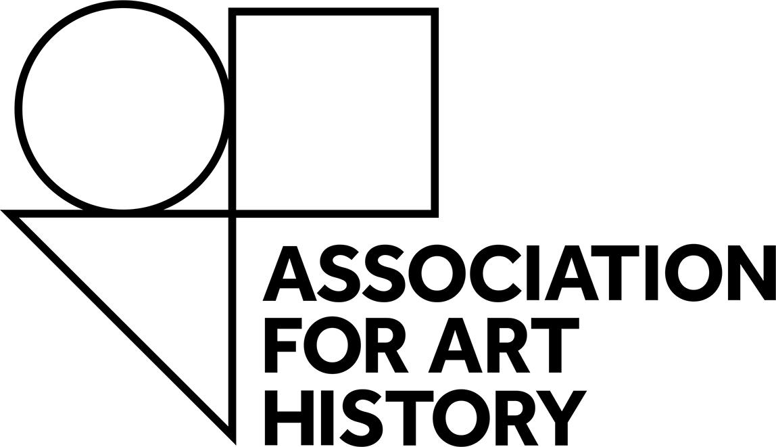

Equality, Diversity and Inclusion

The Association for Art History aims to create and foster an inclusive environment, in our organisation, in our work and across the subject and sector we represent. We want to identify and address the barriers that we and others face in terms of equalities, diversity and inclusion. This is for monitoring purposes and any information provided does not form part of a grant application and is not linked to individual personnel records. All data is separated and anonymised.
Your answers will be treated in strictest confidence, and all data disclosed will comply with the Data Protection Act 1998. You can find out how we manage and process information and data in our Privacy Policy.
The questions that follow relate to some of the protected characteristics under the Equality Act 2010.

Gender:
Male (including female to male trans men)
Female (including male to female trans women)
Non-binary (for example, androgyne)
Prefer not to say

Is your gender identity different to the sex you were assumed to be at birth?
Yes
No
Prefer not to say

Age Group: Less than 18 years 18-24 25-34 35-44 45-54 55-64 65-74 75 or older Prefer not to say

How would you describe your ethnic origin? Tick Box
White | British
 | Irish
 | Gypsy, Roma or Traveller
 | Any other white background, please state
Mixed | White and black Caribbean
 | White and black African
 | White and Asian
 | Any other mixed/ multiple ethnic background, please state
Black/Black British | African
 | Caribbean
 | Any other black/ African/ Caribbean Background, please state
Asian/ Asian British | Asian Bangladeshi
 | Asian Indian
 | Asian Pakistani
 | Chinese
 | Any other Asian background, please state
Other | Arab
 | Any other ethic group
 | Prefer not to say

Alternatively, you can supply a self-definition and you should state what you feel best represents you:

Disability (a disability is defined as a physical or mental impairment which has a substantial and long-term adverse effect on a person’s ability to carry out normal day-to-day activities)

Do you consider yourself to have a disability? Yes No

Where disabled please indicate:
Visual Impairment
Hearing Impairment / deaf
Physical disabilities
Cognitive or learning disabilities
Mental health condition
Other long term / chronic condition
Prefer not to say

How would you describe your sexual orientation?
Bisexual
Gay man
Gay woman / lesbian
Heterosexual / straight
Prefer not to say

Where did you hear about this opportunity:

